Don’t Miss the Trolley!
Sign up for the Historical tour of Rochester on the Rochester Trolley Company
Friday, May 8 - 1:30 p.m. – 5:00 p.m. Pick up at Hilton Hotel Downtown
Cost $35.00

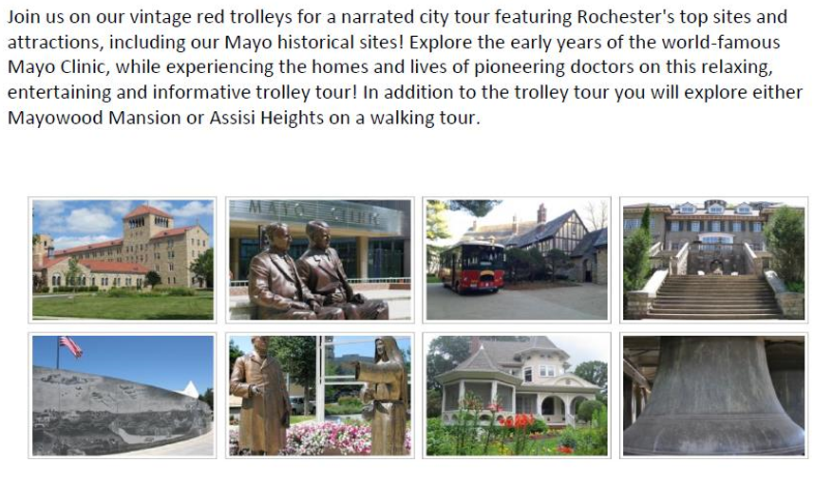
Use the form below to sign up your chorus members.
Deadline for registrations is April 1, 2020
Seats are limited

Send the form and a check for all chorus members registering to go on the tour to:
Jerralyn Tjeerdsma 1300 E. Northstar Lane Sioux Falls, SD 57108-4786 jetjeerdsma@gmail.com
Contact - Terri Calvert 847-909-7365 or tcal01@ameritech.net for information.
Trolley Tour Registration form

Chorus_____________________________________________________________

Members and guests registering for tour @ $35.00 each

Name | Number of Tickets | Amount

Send form and chorus check by April 1 to:
Jerralyn Tjeerdsma 1300 E. Northstar Lane Sioux Falls, SD 57108-4786 jetjeerdsma@gmail.com

