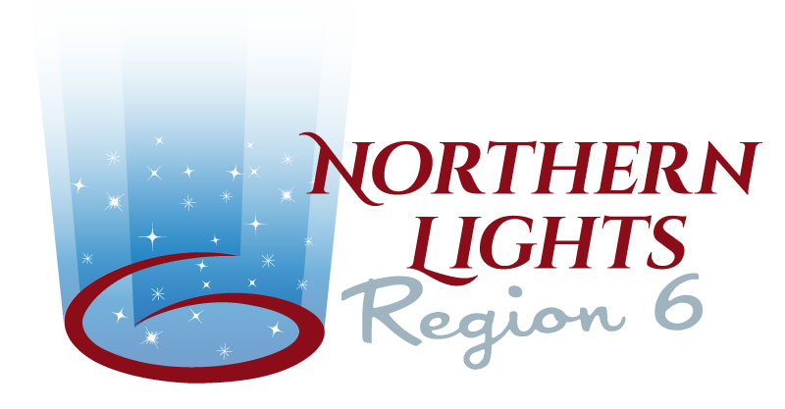

Northern Lights Shining Star Award- 2022

Award:
The Northern Lights Shining Star Award is to acknowledge a Sweet Adeline from within Region 6 who proudly exemplifies the spirit of the Sweet Adeline organization and has contributed to the success and progress of the region through exceptional dedication and enthusiasm.
By broadening the focus on the spirit and not exclusively on leadership at Regional level, outstanding women in the region can be recognized who continue to advance Sweet Adelines International philosophies in their communities and beyond.

The award is a personalized trophy, presented once a year at Regional Convention to a deserving candidate. The award is a once in a lifetime recognition.

Award Criteria:
Recipient
- Displays dedication and commitment to promote and embody the “Harmonize the World” theme of SAI and Region 6 with considerable impact
- Gives her time, talents, and skills generously and selflessly
- Serves to the best of her abilities for the joy of singing and the love of the organization
- Takes an active role at chapter level, participates actively in both chorus and regional activities and functions
- Shows interest in/attends/serves at educational events offered to the membership
- Presents and promotes her chorus, the region, and SAI in the best and most positive way to the general public as a wonderful ambassador
- Demonstrates superior dependability and ‘follow through’, loyalty, and enthusiasm and is an inspiration to fellow Sweet Adelines

Eligibility:
Eligible for the award are present Sweet Adelines members of Northern Lights Region 6, who have been a member of SAI for at least a period of five years. The candidate is an active member in good standing and shows excellent attendance and participation at chorus activities and functions. Nominations of Chapter at Large (CAL) or Associate Members might be taken into consideration if the nominee has a longstanding history of dedication to the region and has shown excellence throughout her active years. Past recipients will not be eligible for future nominations.

Nomination Process:
Each chartered chapter or Member of Region 6 has the privilege of submitting the name of one candidate each year who in its opinion best fulfills the established criteria.
Nominations must be submitted by published Deadline of March 1, 2022. Nominations are to be made by using the nomination form provided by the Region and include a written narrative. The narrative should communicate thoroughly the ways a candidate has served her chapter and the region, and how her service impacts Region 6 and inspires members. It is also helpful to the selection committee to provide quantitative information in the narrative when available to highlight a candidate's commitment and to distinguish her from other nominees.
Chapters are able to nominate their candidate in following years again, if their nominee was not chosen.

Selection Process:
Each year’s recipient will be chosen from the nominations by a selection committee comprised of the Regional Management Team. Candidates fulfilling the largest number of criteria will have the highest chance of being selected.

Presentation of Award:
The award trophy will be presented as a personal keepsake to the recipient at the annual Regional Convention. The presentation should take place during an event when the majority of regional membership is assembled. The recipient will be notified in advance that she was chosen to receive the distinction at the respective year's Regional event and asked to submit a photo to use in publication. The honoree may address the membership briefly after the award presentation, if she desires to do so. Following the presentation, the recipient will be featured in Regional communication and website.

Deadline for submission – March 1, 2022
October 1, 2013

Sweet Adelines International
Janell Mason
Corporate Secretary
PO Box 470168
Tulsa OK 74147-0168

RE: Northern Lights Region 6 – Education Coordinator Applications

Please find enclosed two applications submitted for the Regional Management Team position of Education Coordinator, May 2014—April 2016.

In reviewing the two applications, references submitted and personal knowledge by RMT members, it is our recommendation to accept Cheryl Helm for the position of Education Coordinator. We feel she would be an excellent fit to our team and with her education background would make an outstanding Education Coordinator. The enclosed references submitted on her behalf say it all and support our recommendation.

Thank you for your review and confirmation of Cheryl for this important position.

In Harmony,

Linda Rubis
Communications Coordinator
Northern Lights Region 6

Send to: Linda Rubis, Membership Coordinator
Email: lrubis07@q.com

